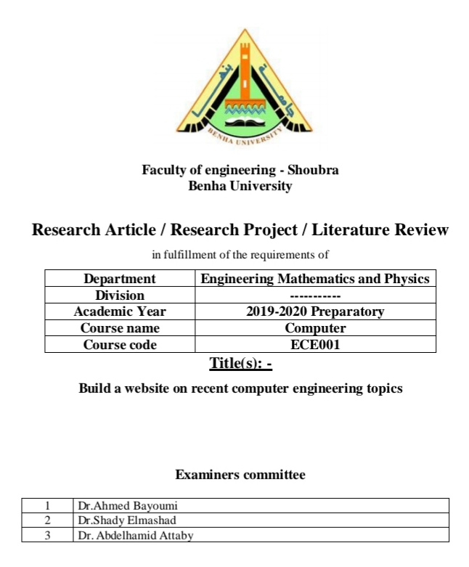Name: **Eslam Khaled Essa**

**178** B.N**:**

Date**: 28/05/2020**

Topic**:** **Artificial Intelligence**

Github link:

**:**Github page

# Application brief:

**Artificial intelligence** **Because of its great importance in human life, it comes in many fields such as education, medicine, and others. It also has a great outlook that compels the world to use it and apply it in various fields.**

**Artificial intelligence (AI) is the simulation of human intelligence processes by machines, especially computer systems. Specific applications of AI include expert systems, natural language processing, speech recognition and machine vision.**

# Advantages and disadvantages of artificial intelligence:

**Artificial neural networks and deep learning artificial intelligence technologies are quickly evolving, and have large amounts of data much faster and make predictions more accurately than humanly possible.**

# The primary disadvantage:

**Of using AI is that it is expensive to process the large amounts of data that AI programming requires.**

# Screenshots:

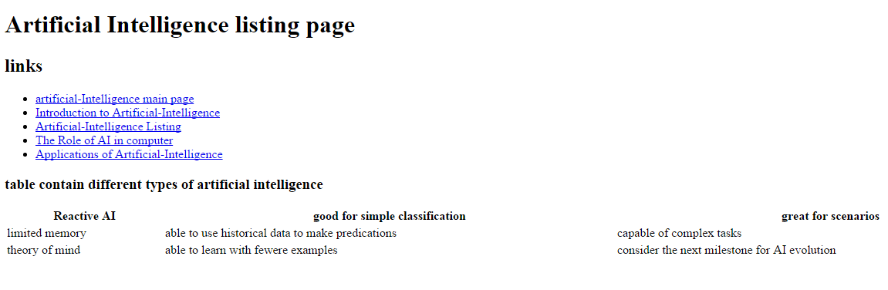

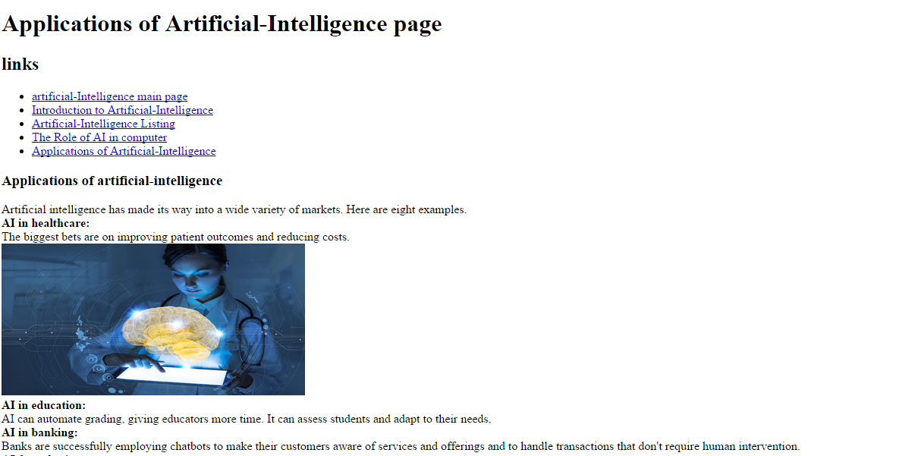

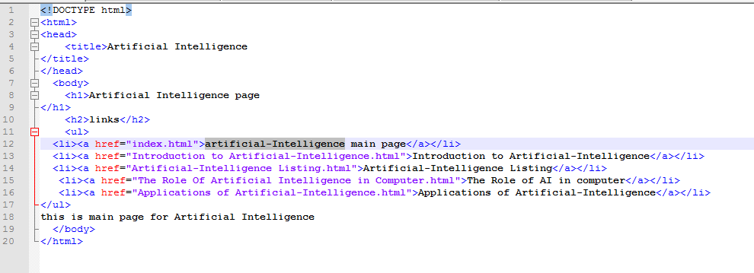Source Code:

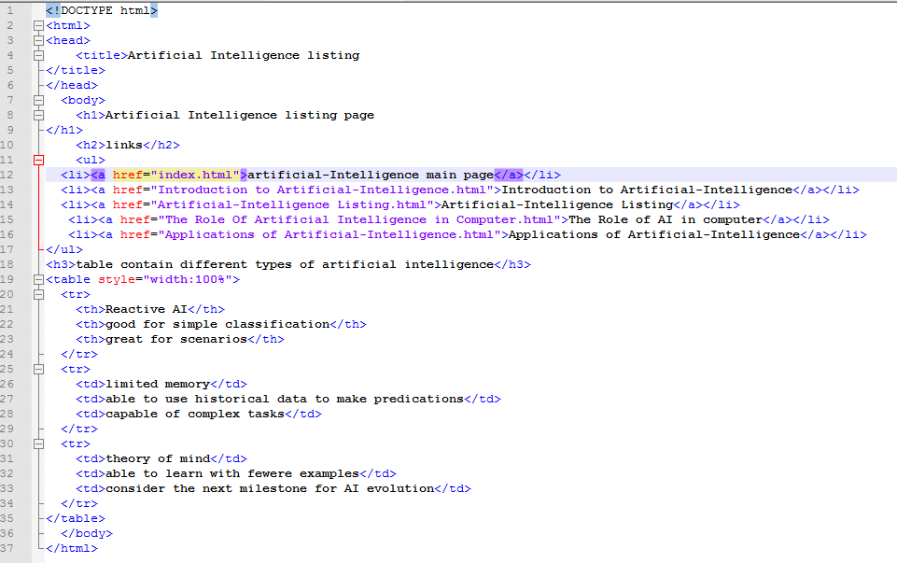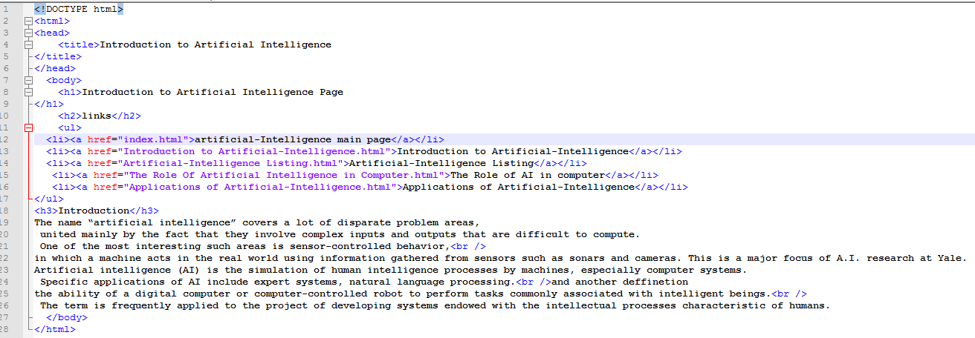

References:

1-Kyun, S., Yi, J. and Kwon, S., 2018. Students perception of universities introduction of artificial intelligence and of the artificial intelligence professors. The Education Research Institute, 16(3), pp.77-101.

2-Artificial Intelligence, 1987. Artificial intelligence abstracts. 32(3), pp.414-415

3-Pedersen, T. and Johansen, C., 2019. Behavioural artificial intelligence: an agenda for systematic empirical studies of artificial inference. AI & SOCIETY,.

4-Artificial Intelligence, 1997. Special issue of Artificial Intelligence on applications of AI. 95(2), pp.439-440.